Game Design Document: Keep it Cool (GMTK 2026)

Summary & Overview
Project Title: Keep it Cool (Working Title)
Event: GMTK Game Jam 2026
Jam Theme: Count Down
Engine: Godot Engine 4.7.x (2D Top-Down or Isometric)
Team Size: 6 Contributors (Audio, Graphic Design, Programming, Level Design, Narration)
Setting & Aesthetics: 1950s Steampunk / Retro-Futuristic Industrial. Heavy brass, glowing vacuum tubes, copper pipes, hiss of steam, combined with 1950s mid-century aesthetic accents (diners, vinyl seats, retro posters).
Core Concept: You play as an autonomous maintenance robot working on a moving train. To survive, you must solve grid-based spatial puzzles to navigate from carriage to carriage. As you travel deeper into the train, the atmosphere shifts from the benevolent PETR (People for the Ethical Treatment of Robots) section to the oppressive PUTR (People for the Unethical Treatment of Robots) section. The robot is deteriorating and needs to get to the repair station in front of the train, while also fulfilling its duties as a service robot.
Primary Twist & Theme Fit: You face a double countdown. A global 15 minute real-time clock before you are broken beyond repair, and a local Cool Fuel deplete meter in every carriage that forces tactical recharges from fuel stations. These fuel stations will have a limited amount or charges available, so the player has to be tactical about their approach of each carriage level.

Core Gameplay Loop & Rules
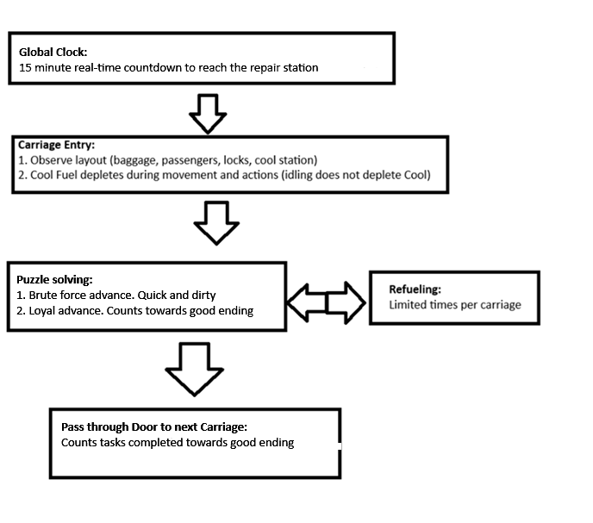

High-Level Rules
- Linear Progression. The train consists of carriages connected sequential and can be layered on multiple levels (top-floor, main-floor and “basement” (below the deck))
- Global Hard Time Limit: You have exactly 15 minutes from the start of carriage 1 to reach the final engine room and perform the final repair.
- Local energy: Every step of movement, passenger interaction, object interaction or use of a special ability, drains the Cool Fuel meter. When this meter reaches zero, the robot shuts down and the carriage level will be restarted (costing global clock time.)

Energy & Time Systems
The game will implement the jams theme “Count Down” across two interconnected gameplay layers.

Global countdown
- 15-minute overall gameplay time per run
- Only indicated by a changing background and at the start of a level (“I have x minutes until we reach the final station.”)
- Timer ticks down continuously in real-time during gameplay and puzzle solving
- Timer is paused during dialog UI popups in order to give the player a breather and to engage in the story without the need to rush it
- Failure condition: When the timer runs out before the player reaches the final repair coach, the robot dies and will be dismantled (Bad ending: Out of Commission)

Local countdown
- Cool Fuel Meter: The robot’s internal boiler runs on Cool, a rare 1950s steampunk mineral that generates a steam continuously, without the need of combustion.
- Fuel Consumption:
  - Timer based consumption/idle: 0% per second, increases with 0.5% after each (two in total) story related catastrophes that lead to a leaky boiler.
  - Tile Movement: 1.0% per grid tile
  - Pushing regular object: 2.0% per grid tile
  - Pushing heavy object: 3.5% per grid tile
  - Moving Passenger: 5.0% per grid tile
- Cool Fuel Station: Each carriage has 1-2 active fuel station containing a fixed pool of Cool mineral refills. When a station is depleted of Cool, an indicator light on it starts to flash red.

Puzzle Mechanics & Escalation
Puzzles are solved on a tile grid. Ladders and stairs allow the player to move between different levels of a carriage (if present).

Primary Puzzle Elements
- Baggage Clearing:
  - Light Crate: Can be pushed into an empty space, regular object cost
  - Heavy Trunk: Can be pushed into an empty space, heavy object cost
  - Fragile Cargo: Will break on impact with another object, regular object cost
- Passenger Relocation:
  - Passengers can block passages, doors or collectable items
  - Passengers have preferences:
    - Default passenger: Will remain on a tile that contains a bench, bar stool, coffee tray or radio
    - Special passenger: Interactable with a dialog box and gives a hint what their preference is.
  - Passengers that are placed on a tile fitting their preference will remain here and give a positive count to the players alignment score
  - Willpower mechanic. Some passengers have a high willpower and will move back to their original stop when placed on a neutral or unfavorable tile
- Key Items & Tools:
  - Brass door key / punch card: Sometimes needed to advance to the next carriage
  - Oil can: Lubricates luggage to move with lower fuel cost or lets passenger slip and slide, knocking them unconscious and make them movable like objects
  - Free Coffee coupon: Give to a passenger to move voluntarily out of the carriage through the entry door of the carriage.

Level Design Curve & Escalation
Carriage number | Atmosphere | Puzzle Focus | Servant goal
1 | PETR Lounge Coach (Bright, blue, brass, cozy) | Tutorial 1: Basic tile movement. Pushing a few light luggage pieces | Passengers cheer you on and are not in the way. Fixed positive score that only goes down when pushing luggage into passengers
2 | PETR Dining Coach | Tutorial 2: Introducing multi-level carriage and passenger relocation | Easy placement. Passengers thank the robot for placing them on a favorable tile. Critique for placing them on an unfavorable tile.
3 | Standard Coach | Luggage chains + special need passengers with high willpower. First tight Cool limit. First leak appears | Choose to find personal item of special passenger (+ score) or use oil to knock unconscious and move (- score)
4 | Sleeping Coach | Dark hallway with candle light. Sleeping passengers in the hallway. Waking them up (breaking fragile cargo) will make them block doors | Stealth maneuvering and personal tasks (+ score) vs forceful moving sleeping passengers (- score)
5 | PUTR Guard Coach (grim, dark steel, red, rusty cages) | High willpower passengers. Robot guards that have to be dodged, or they push you out. Cool trap that drains your Cool with -50%. Second leak appears. | Disarm the trap from underneath the carriage and favor demanding passengers (+ score) or lure a robot guard over the trap (- score)
6 | Repair station | Bars shut both exits. Red flashing lights. 02:00 countdown starts. Maneuver a maze to reach the repair station. Robot loses core functionalities while advancing | No ethical choice. Need to reach the end.

Narrative, Servitude & Ending

Factions
- PETR (People for the Ethical Treatment of Robots): Mid-century idealists who view robots as sentient partners. Their carriages are ornate, well-lit and blue themed.
- PUTR (People for the Unethical Treatment of Robots): Industrialists who view robots as disposable tools to be forced to work till they break down. Their carriages are industrial, dark, rusted and red.

Servitude system
Robots are considered in both factions as an entity that serves humans. The player has to perform tasks for the passengers in order to gain servitude score. This score is hidden from the player during the run and determines the outcome of the game if the player manages to reach the end. At the end of the game, the player will see their final score and is able to submit this to a high score board.
- Positive score modifiers
  - Placing default passengers in enjoyable seats (+5)
  - Giving a passenger a free coffee coupon (+5)
  - Performing tasks:
    - Recover a requested item from a passenger (+10)
    - Perform maintenance to the train interior (+10)
    - Clear the main path of luggage (+2)
- Negative score modifier
  - Placing passengers on unfavorable tiles (-5)
  - Destroying fragile cargo (-5)
  - Use an Oil Can to knock a passenger unconscious (-10)
  - Ignoring a core task in a carriage (-5 per missed task)

Ending Matrix
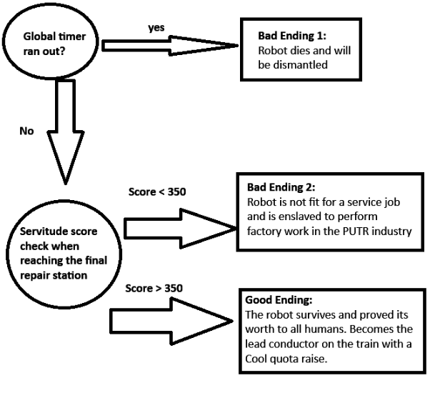

Team Scope
The team consists of the following roles
- Lead Audio Design (Bolton)
  - Produce a 1950’s inspired steampunk ambient soundtrack
  - Produce SFX for the train, passengers and player character
- Lead Systems & UI Engineer Godot (Haaxor)
  - Program player movement
  - Create scoring system and balance it
  - Create a main menu and UI elements
  - Create carriage scene transitions
- Lead Pixel art/2D Artist (Rocsa)
  - Create pixel art for the player and passengers
  - Create (tilemap for) carriages fitting different themes (PETR, Neutral and PUTR)
  - Create props to be placed as a puzzle mechanic
- Lead Level Building & Gameplay (Sheal)
  - Create design document
  - Create puzzles and passenger tasks
  - Create and balance Cool consumption system
  - Create and balance Passenger willpower mechanic
- Lead Narrative and Story Telling (DesignerDave)
  - Write overall story
  - Write carriage dialogue snippets
  - Create dialogue decision making
  - Create special passengers with tasks and needs

